|  |  |
| --- | --- |
|  |  |
| **Winter 2019** | **Serving Butler & Preble counties in Ohio Volume 48** |
| **We’re on social**  **media!**  [facebook](facebook.com/amvohio/)  [@audubonmv](https://twitter.com/audubonmv)  In This Issue   * Remembering John Blocher * Winterizing for Wildlife * Lessons from Namibia * Belize Reflection * Upcoming Field Trips * Winter Programs   **AMV 2019 OFFICERS**  President Linda Williams  [lwilliams@amvohio.org](mailto:lwilliams@amvohio.org)  Vice President Larry Gersbach  [lgersbach@amvohio.org](mailto:lgersbach@amvohio.org)  Treasurer  Neil Poppendeck  npoppendeck@amvohio.org  Secretary   Gail Reynolds  [greynolds@amvohio.org](mailto:greynolds@amvohio.org) | We're happy to send you Audubon Miami Valley's (AMV) winter newsletter. AMV plans a full line-up of meetings and events this winter. Find the details both in this newsletter and at our website [amvohio.org](https://amvohio.org/)  Remembering John Blocher  John Blocher began visiting Audubon meetings around 1980. He soon volunteered to be the newsletter editor and later served as bird seed sale coordinator, treasurer and president. After leaving the Board he continued to attend many Audubon activities through spring of 2019 when he passed at the age of 100 years.  John and Phyllis lived where Robert Hefner had created a preserve from a hog wallow south of Oxford. John became Curator of Miami U’s Silvoor Nature Preserve mastering wildflowers, trees and birds and recruiting many people to remove Amur Honeysuckle. When the sun finally warmed the woodland floor, Blue-Eyed Marys and other beautiful plants rose in abundance.  John led the editing team who published a book compilation of “Silvoor Notes” of Hefner's selected Oxford Press columns. Then, John made sure that much of the hillsides of several adjacent private properties became permanently protected by Three Valley Conservation Trust. To read more about John [click here](https://tinyurl.com/yhfkqhmw)    Winterizing for Wildlife  Image result for bird in the snow audubon"* Attract birds with suet and other high-calorie foods such as peanut butter and chopped nuts. Nuthatches, Downy, Hairy and Red-bellied woodpeckers love it - and it's a thrill when a Pileated woodpecker announces its visit to my suet feeder!  * Keep a source of clean water available. Consider using a birdbath heater in   freezing weather.  * Provide shelter from cold and predators with a brush pile of fallen branches, twigs,   and leaves.  * Dream of spring planting - native plants offer food such as pollen, nectar, nuts,   cones, berries, and seeds, and evergreens provide cover.  **We can help support the birds we love!**  Lessons from Namibia  *As told by AMV scholarship winner Shara Clark –*  As I embarked on 20+ hours of travel to Namibia, I was excited but anxious. I had never been to Africa. Never been to the southern hemisphere. Never been away from home for that long. Would it be worth it? The answer is a resounding, yes! This life-changing experience was more than I could have ever imagined. Besides the gorgeous views and seeing amazing animals in the wild, all that I learned about Namibia, its people, and the challenges they face are lessons that will stick with me for a lifetime. |

|  |  |
| --- | --- |
| **MEMBERS-AT-LARGE**  Marlene Hoffman [mfhoffman@amvohio.org](mailto:mfhoffman@amvohio.org)  Randy Morgan [rmorgan@amvohio.org](mailto:mgilmore@amvohio.org)  Steve Sullivan  ssullivan@amvohio.org  Mickey Simonds [msimonds@amvohio.org](mailto:mgilmore@amvohio.org)  Carly Zeis [czeis@amvohio.org](mailto:mgilmore@amvohio.org)  **APPOINTED COMMITTEE CHAIRS**  Audit  Citizen Science  Larry Gersbach  [lgersbach@amvohio.org](mailto:lgersbach@amvohio.org)  Conservation Dick Munson  [dmunson@amvohio.org](mailto:dmunson@amvohio.org)  Conservation Advocacy  Carly Zeis  czeis@amvohio.org  Education Libby Birch  [lbirch@amvohio.org](mailto:lbirch@amvohio.org)  Field Trips Eric Hollins  ehollins@amvohio.org  Finance  Neil Poppendeck  [npoppendeck@amvohio.org](mailto:npoppendeck@amvohio.org)  Membership Beverly Thomas  [bthomas@amvohio.org](mailto:bthomas@amvohio.org)  Newsletter   Alexandria Horne   [ahorne@amvohio.org](mailto:ahorne@amvohio.org)  Programs  Hardy Eshbaugh  [heshbaugh@amvohio.org](mailto:heshbaugh@amvohio.org)   Website  Liz Woedl  lwoedl@amvohio.org | I had the pleasure of visiting Etosha National Park and studying at The Cheetah Conservation Fund in Otjiwarongo. What I found were amazing staff and volunteers who are dedicated not just to saving the dwindling cheetah population (there are less than 7,100 in the wild) but to protecting all wildlife in a way that also enhances the local community.  CCF is the epitome of community-based conservation as they attack issues from all angles. Local farmers have been known to kill cheetahs because they believe they are attacking their livestock. However, CCF has worked to educate farmers to show that cheetahs are not usually the culprits. They train farmers on their model farm and provide livestock guarding dogs. Their scat detection dogs help find samples to study in their on-site lab where they have built up the largest bank of cheetah genetics in the world. In addition, CCF is taking on the illegal pet trade, educating thousands of children and visitors about cheetahs, and is fighting bush encroachment through their Bushblok program that turns acacia into a safer fuel source. It was inspiring to see their work and learn how they are making an impact. If you’d like to learn more about their efforts, visit [cheetah.org](www.cheetah.org)  *Shara at CCF*   Belize Reflection  *As told by AMV scholarship winner Leah Goeke-*  Hello! My name is Leah Goeke. Not only am I a wife, mother, and fifth grade teacher in Centerville, Ohio but I am also a third-year master’s student in the Advanced Inquiry Program (AIP) at Miami University (a joint program with the Cincinnati Zoo & Botanical Garden).  For the past three years I have been working to give my students (and community) inquiry opportunities to limit single use plastics. I have asked my students to come up with an impact project to solve this global issue, and each year I have  *Leah at Tobacco Caye* been blown away by the results. During the 2017-2018 school   year my students chose to start a campaign to collect single use  plastic grocery bags. They then cut them into plastic yarn (plarn) to be crocheted into sleeping mats for the homeless by me. In the 2018-2019 school year my students chose to host cleanups in a local park to limit the amount of anthropogenic debris that was entering Holes Creek, which was so eye opening-we collected hundreds of pieces of debris.  In order to further my studies, this summer, with the help of The Rosie Bloom Scholarship, I traveled to Belize for 18 days with [Project Dragonfly’s Earth Expeditions](https://projectdragonfly.miamioh.edu/earth-expeditions/).  I was enticed by the course description “Discover the power of inquiry to generate knowledge and inspire conservation. All students will have the chance to conduct an investigation of the local ecosystem, asking their own questions, collecting data, and presenting conclusions.” Originally, I just wanted to see how plastic and other human debris was impacting a country located on the coastline, however, I gained so much more.  Yes, plastic was riddling their areas, which was so hard for me to look at. I noticed that wherever there were humans, there was plastic and debris-much like what I see here in Ohio. It made me angry at everyone. I almost let it cloud my view of conservation, but then we visited the [Community Baboon Sanctuary.](http://www.belizehowlermonkeys.org/) |

The Community Baboon Sanctuary (CBS) was founded by Dr. Robert Horwich, an American primatologist and Fallet Young, in 1985. Horwich, a landowner in the village of Bermudian Landing, pioneered a voluntary grassroots conservation movement to help sustain the habitat of the Black Howler Monkey (called ‘baboon’ in the local Creole dialect). What started with 12 participants has grown to over 200 private landowners in seven villages. Each participant has pledged to conserve their land for the protection of the Black Howler Monkey (the population has risen to over 2,000). This has also led to the conservation of local plants, more education programs, as well as landowners benefitting from ecotourism.

During this visit I also had the opportunity to stay in the home of a local retired teacher. She told me more about growing up in the community. Walking to school they would be right there with the howler monkeys. No one threw things at them or bothered with them in the slightest-they just respected them. While they do not have much money, they are rich in community and love.

This stuck with me. Upon returning home to Ohio, I switched gears from looking at the abundance of debris in an area and have been researching the best methods for sharing conservation methods. My hope is to create change in not only my school district but also in my community.

# Upcoming Field Trips

Each month between September and June, Audubon Miami Valley sponsors a field trip to a regional site of special interest. All are welcome on AMV field trips. More information is available [here](http://amvohio.org/events/field-trips/) or send an email to Eric Hollins, AMV field trip coordinator, at [ehollins@amvohio.org](mailto:ehollins@amvohio.org) Please join us even if you don't have binoculars; AMV members are always happy to share and help beginning birders.

**Brookville Lake Area – Saturday, December 7, 2019**

Ornithologist Dr. David Russell will again lead us on a birding tour of the Brookville Reservoir area between Liberty and Brookville, Indiana. We’ll visit a number of good spots around Brookville Lake as well as Whitewater State Park, looking for migrating ducks, geese, gulls, sandhill cranes and other species. The group will meet at 7:30 a.m. at the west end of the Wal Mart parking lot (on US 27, north of Oxford). Pack food if desired.

**Hueston Woods State Park – Saturday, February 22, 2020**

We will visit several of the popular birding areas at AMV’s “home park”. Early spring migrants will be arriving in addition to populations of overwintering birds. Park Naturalist Kathryn Zeppernick will host our visit. The trip will meet at the Hueston Woods Nature Center at 10:00 am. Pack a picnic lunch or snacks if desired. We will plan to enjoy lunch inside the Nature Center, where we can observe birds visiting the feeders just outside. Hueston Woods is recognized by Audubon as an Important Bird Area and includes the 200 acre “Big Woods”, a designated National Natural Landmark by the National Park Service. AMV adopted the HW IBA as a stewardship project in 2012 and has conducted habitat restoration events every spring and fall since then.

**The Oxbow – Saturday, March 21, 2020**

This area of migratory shorebird and waterfowl habitat is preserved and protected by The Oxbow, Inc. Local area expert and birder/naturalist Gary Stegner will host our visit and guide us to the best locations, which vary seasonally with changing water levels. The trip will meet at the TJ Maxx parking lot at 8:00 am for the 1-hour drive to the preserve. If traveling directly to the site, search for “Oxbow Nature Conservancy” on Google maps, or contact Eric Hollins, AMV field trip coordinator, at ehollins@amvohio.org. Pack a picnic lunch or snacks if desired. In the spring and fall thousands of ducks, geese, and shorebirds funnel into this rich stopover area to refuel and rebuild their energies. Since 1985, Oxbow, Inc. has led the effort to acquire over 1,600 acres of wetland through ownership or conservation easements to protect this resource.

**The Highlands Nature Sanctuary – Saturday, April 25, 2020**

This is a 2,600-acre nature preserve owned and managed by the non-profit Arc of Appalachia. It features 15 trails providing access to the scenic geology, well preserved forests and exceptional spring wildflowers of the region. The trip will meet at the TJ Maxx parking lot at 7:30 am for the 2-hour drive to the sanctuary. Pack a picnic lunch or snacks if desired. We will plan to enjoy lunch inside the Nature Center. If traveling directly to the site, the destination address is 7660 Cave Rd., Bainbridge OH 45612. Information about Arc of Appalachia and the Sanctuary is available [here](http://arcofappalachia.org). Beginning in 1995, the Arc has acquired over 1,600 acres of forest habitats and currently stewards twenty preserve regions.

# Upcoming Audubon Miami Valley Programs

AMV will meet on the following dates at 7:30 PM in the 2nd floor conference room of the Lebanon Citizens National Bank building, 30 West Park Place, Oxford, OH. These meetings are free and open to the public.

**December 9, 2019 “A Romp through Ohio’s Flora and Fauna“**

**Presenter - Jim McCormac**

This program will be a pictorial adventure; a wander through Ohio’s varied habitats with visits to flora and fauna great and small. We’ll look at well-known plants and animals, and obscure species that few have heard of or encountered. Overarching all is the importance of ALL the cogs of the ecological wheel, and the need to protect everything. Jim worked for the Ohio Department of Natural Resources for 31 years as a botanist, and later specializing in wildlife diversity projects, especially involving birds.   
 **February 10, 2020 Our Maine Summer Adventure   
Presenters - Adriane and Flora Ruther**We are very appreciative of the opportunity provided by AMV to visit Hog Island in Maine. Our experiences included a week of amazing people, incredible maritime island exploration, delicious food, gorgeous wildlife, and fun crafts, songs, and games along the way. We are excited to share our adventure with you! Adriane has been teaching biology and botany at Talawanda High School since 2004. She also serves as the district Sustainability Coordinator and advises the Environment and Natural Science Club. In her spare time, she likes to hike, bike, sew, and read. Flora is 9 and in 4th grade at Bogan Elementary. She loves reading, drawing, swimming, gymnastics, and dance.

**March 9, 2020 A Mexican Odyssey – Birding the Puerto Vallarta – San Blas region**

**Presenter – Hardy Eshbaugh**

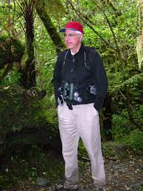Birding in the Pacific coastal region of Mexico introduces the birder to numerous tropical and sub-tropical species as well as some very unusual endemics. Travel with Hardy as he introduces us to the avifauna of this region that is too often overwhelmed by the tourism market yet holds many surprises hidden in out of the way corners of Nayarit and Jalisco. Hardy is a professor emeritus at Miami University. During his many years as a professor he taught a range of courses including field courses in the Bahamas, Nova Scotia and Newfoundland, and the Peruvian Amazon; he has seen more than 1,800 bird species. Hardy has led ecotourism trips all over the globe.

**April 13, 2020 Elephants, Lions and Lapwings: A Southern Africa Safari  
Presenters - Kathy Beil-Morgan and Randy Morgan**

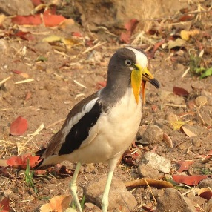We’ll feature some natural history highlights from our vacation expedition to Namibia, Botswana, Zimbabwe and South Africa. Deserts bisected by wetlands and bordered by coastlines support incredible wildlife such as elephants, lions, wild dogs, rhinos, hippos, antelopes, crocodiles and more. Diverse birdlife includes ostriches, fish eagles, iridescent sunbirds and starlings, bizarre hamerkop and hoopoe. Kathy Beil-Morgan is currently Marketing Manager & Veterinary Nurse at Peach Grove Animal Hospital. She is a retired Procter & Gamble Consumer Researcher. Randy Morgan holds the honorary position of Emeritus Curator-Insectarium, Cincinnati Zoo & Botanical Garden, where he worked for 32 years prior to retiring. He is also a Board Member-at-large for AMV.

**May 11, 2020 Giant Panda Conservation and the Global Goals for Sustainability   
Presenter – Nancy Ferguson**

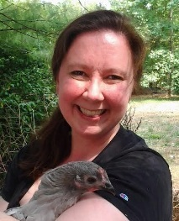Nancy Ferguson Robinson will present a program on Giant Panda Conservation and the Global Goals for Sustainability. Nancy will discuss Giant Panda conservation and her role as an envoy to the United Nations Development Programme. In January 2017, Nancy traveled to China to learn about the challenges of Giant Panda conservation and understand the role of Giant Pandas as ambassadors of hope for the Global Goals. Nancy is currently the Director of Counseling Services at Miami University Middletown. From 1993-2004 Nancy’s work focused upon good health, gender equality and violence prevention as director of a regional rape crisis center. Her background includes consultation for the Peace Corps and Ministry of Health in Dominica, West Indies. Nancy also worked as a naturalist educator/Program Leader at the Cincinnati Zoo, teaching about wildlife conservation, biodiversity and animal adaptations.

Audubon Christmas Bird Count  
*The nation's longest-running community science bird project fuels Audubon's work throughout the year.*

Be a part of the National Audubon Society’s 120th winter bird census, involving thousands of volunteers across the U.S., Canada, and other countries. AMV is responsible for the census in a 15-mile diameter circle around Oxford. Participants work in groups, so both experienced and inexperienced birders are welcome. Plan to stay for a pot-luck lunch after the count.

The count is on **Saturday, December 14th**. We will gather at **7:00 AM** at the **Miami University Ecology Research Center**, **5806 Somerville Road in Oxford**. Dress warmly, wear boots and a bright jacket, and bring binoculars if possible. For lunch, bring your own table service and, if you wish, a covered dish to share.

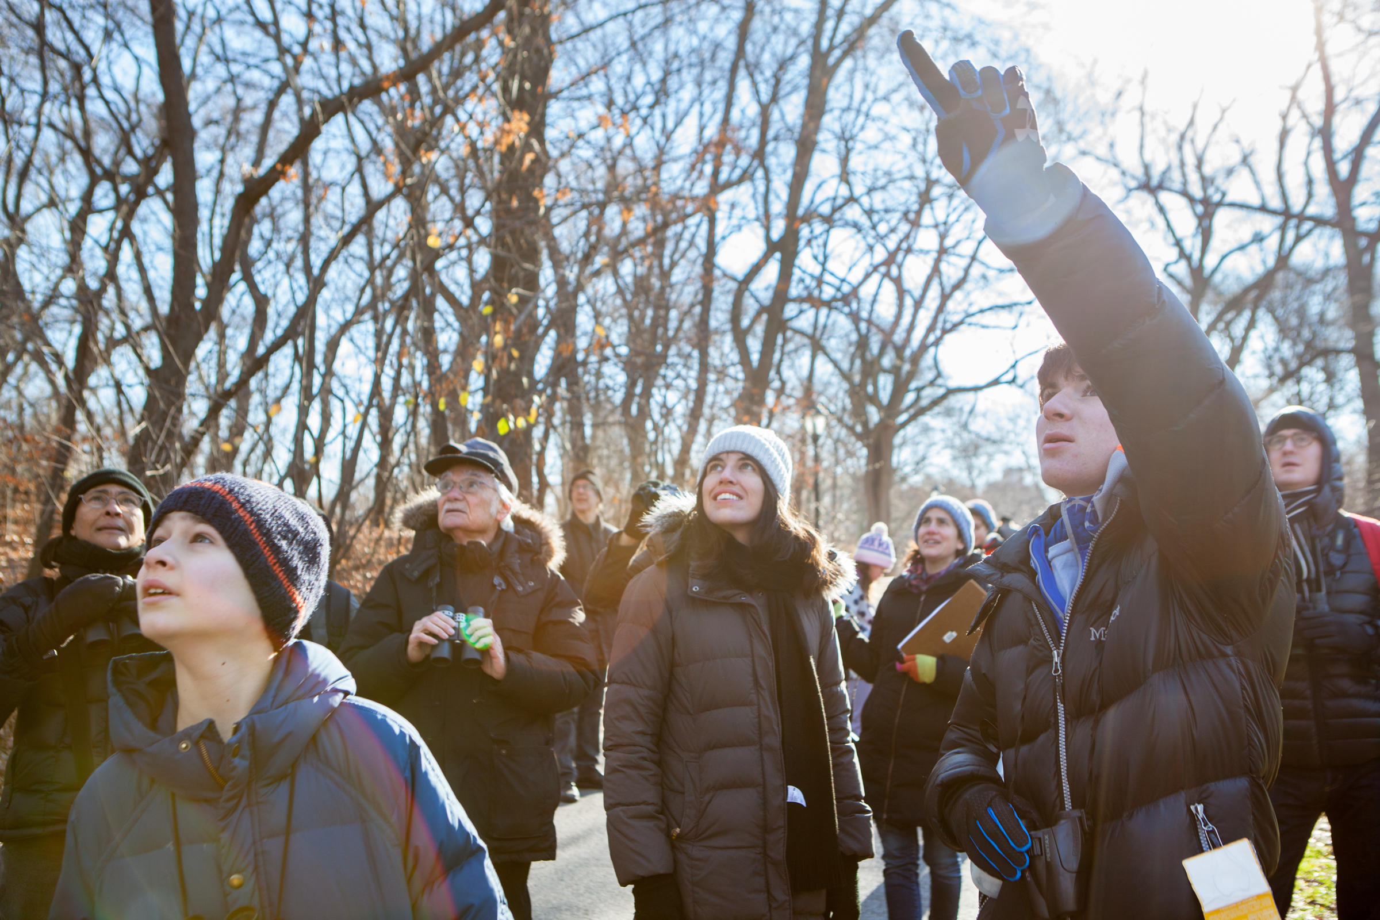



## OUR MISSION

Audubon Miami Valley works to conserve and restore natural ecosystems, focusing on birds, other wildlife, and their habitats for the benefit of humanity and the earth’s biological diversity.

The Audubon Miami Valley newsletter is published three times a year. Alexandria Horne is the editor. Bev Thomas is the proofreader. Caitlin Stone designed the AMV Meadowlark logo. The paper version of the newsletter is printed by Letterman Printing in Oxford on 100% recycled paper.

If you would like to contribute content to the newsletter, please send your content to [ahorne@amvohio.org](mailto:ahorne@amvohio.org)

or to Newsletter, P.O. Box 556, Oxford, Ohio 45056. Contribution deadline for the Spring 2020 newsletter

is March 1st.

## We seek to shape a culture in which the violation of nature is

## socially, politically, and morally unacceptable.